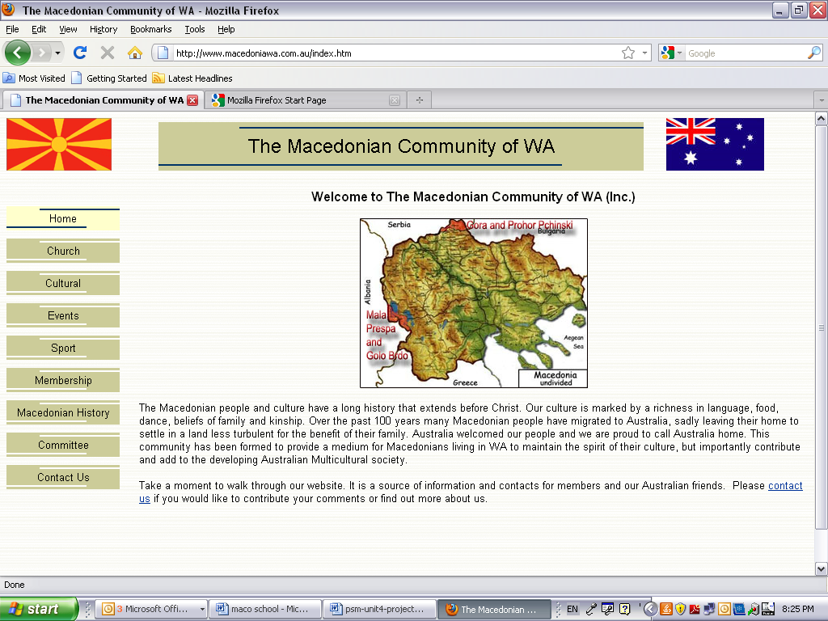
Newsletter No. 1, March 2012
MACEDONIAN LANGUAGE SCHOOL
SKOLO ZA MAKEDONSKI JAZIK

Welcome
Welcome to the very first edition of the Macedonian Language School Newsletter. This newsletter is to provide details and information about our Macedonian Community language school. Please read on for some useful information and to find out what is coming up.

Expressions of Interest
What a great response the Macedonian Community of Western Australia (Inc) has received to its call for Expressions of Interest from families and their children to learn the Macedonian language. Thank you. This was the first step in planning for the establishment of our Community language school.

All data received indicates that there is strong support from the Community for a Macedonian language school. The Committee of the Macedonian Community of WA Inc recognises the value of language learning for future generations and is proud to support and implement this initiative.

Please continue to spread the word. Expressions of Interest continue to remain open due to Community demand.

Aim of the Macedonian Language School
The aim of the Macedonian language school, amongst other things, is to maintain the Macedonian language and culture and develop confidence in all students to use the language.

The Macedonian language school will provide language and culture to all individuals irrespective of their background, religion or gender.

School Commencement Date
Macedonian language classes will commence at the beginning of Semester 2, 2012, i.e. Term 3, Tuesday 24th July 2012 (as per term dates for public schools in Western Australia).

Registration
All families and their children who have expressed interest in learning the Macedonian language will shortly receive details of registration and class times. The scheduling of class times will be based on the majority of preferences received from the Community. It may not be possible to accommodate every student’s preferred time. Should this be the case you will be contacted by the Language Co-ordinator to discuss an alternative day and time. Every endeavour will be made to accommodate student requests, where possible.

Contact Us
The Committee’s job can only be effective if we have feedback (the good and the bad) from you to ensure continuous improvement and make our Macedonian language school a successful one.

For language school related enquires please email language@macedoniawa.com.au.
For general enquiries please email admin@macedoniawa.com.au or telephone 9328 7852.

All suggestions are welcome.

Tutorial Segment
Don’t know the Macedonian alphabet but would like to learn? Visit http://www.youtube.com/watch?v=CkIl5u0ELXA.

