
Newsletter No. 4, December 2013
MACEDONIAN COMMUNITY LANGUAGE SCHOOL

ŠKOLO ZA MAKEDONSKI JAZIK
Thanks and Season’s Greetings from the Chairman
Welcome to the final edition of the Macedonian Community Language School Newsletter for 2013 and the end of another school year. The Macedonian Community Language School has now been operational for two years. During this time we have witnessed great progress in student proficiency and confidence. I would like to thank the Board members, our teachers who provide opportunity for our students to learn the Macedonian language and our sponsors and volunteers for their ongoing support. I would also like to invite and encourage existing students to continue their language learning and welcome new students in 2014. May you all have an enjoyable festive season and holiday period. I look forward to your continued support in 2014. Среќен Божиќ и Среќна Нова Година – Peter Vassileff.
Summer Course
If you speak Macedonian and would like to learn how to read and write then this is just for you. The Macedonian Community Language School is holding a 6 week summer course for Macedonian speakers who would like to learn the Cyrillic alphabet. Classes will be held fortnightly from Friday, 28 February 2014 to Friday, 9 May 2014, starting at 6.30pm and finishing at 8.00pm. All classes will conclude with a light supper and glass of wine. Cost of this 6 weekly summer course is $120.00, all inclusive. Should you be interested in attending summer classes, having some fun along the way and reconnecting with old friends, please email you name and contact details to language@macedoniawa.com.au.
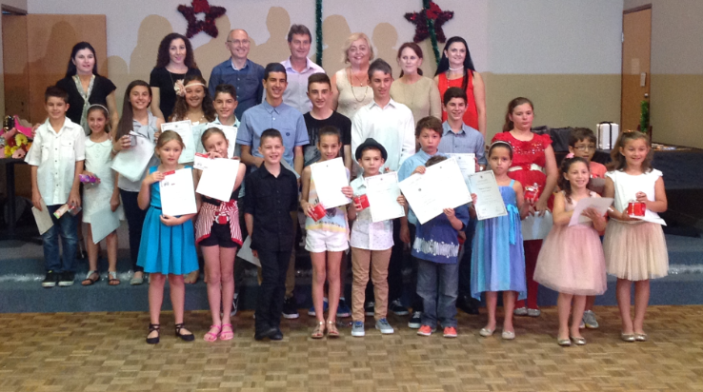
Awards Night
On 23 November 2013, at a combined Cultural and Language School Awards Night, the Macedonian Community Language School acknowledged its student for their academic efforts and achievements. Congratulations to all students and best wishes for your continued language studies in 2014. Keep up the good work.
2014 School Board
Welcome to new members. Board membership for 2014 comprise Mr Peter Vassileff (Chairperson), Ms Kathleen Lazaridis (Director), Mr George Naoum, Mr John Kirou, Ms Feni Bembridge and Ms Corrinna Polites. Special thanks goes to Mr Philip Paioff who has resigned from the Board this year. Mr Paioff was an inaugural member of the School Board and we would like to thank him for the invaluable contribution he has made to our School. We hope to see him back in the future.
Language Teacher Wanted
The Macedonian Community Language School is seeking the services of a teacher to deliver Macedonian language classes after hours (Weekdays/Saturday). Applicants must be professional, flexible and willing to support extracurricular activities. Interested persons should send their CV along with the names and contact details for two referees to the Director, Macedonian Community Language School, Macedonian Community of Western Australia (Inc.), PO Box 12, North Perth, Western Australia, 6906 or via email to language@macedoniawa.com.au.
2014 School Enrolments
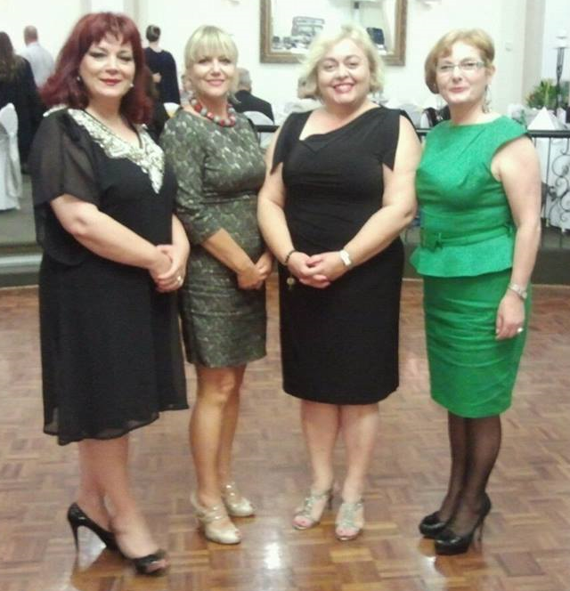
Enrolments for 2014 are now open. To obtain an enrolment form please visit www.macedoniawa.com.au and select Language Classes. Details on how to submit your enrolment form are listed on the bottom of the page. All payments received prior to 27 January 2014 will receive a 10% discount. For further information please contact the Macedonian Community of WA Inc on 9328 7852 or email language@macedoniawa.com.au. All are welcome and background in the Macedonian language is not essential. Please tell your friends that Macedonian Community Language School enrolments for 2014 are now open.
National Meeting of Language Representatives
On 1 December 2013, Macedonian language representatives from New South Wales, Victoria and Western Australia met in Melbourne at the Year 12 Macedonian Graduation Ball organised by the Macedonian Teachers’ Association of Victoria. Representatives grabbed this opportunity to discuss how the respective States can work together to connect and work on a national level to promote the Macedonian language. Pictured (L-R), Zakalina Mihajlova, President, Macedonian School Council of New South Wales, Lidija Narasanova-Smilevska, Consultant and Educator from the Republic of Macedonia, Kathleen Lazaridis, Director, Macedonian Community Language School, Western Australia and Lubica Talevska, President, Macedonian Teachers Association of Victoria. Ms Narasanova arrived in Australia in August 2013 and is the first assistant to be sent from the Republic of Macedonia to assist Macedonian schools and teachers in Australia.
Contact Us
For language school related enquires please email language@macedoniawa.com.au.

