
Newsletter No. 3, October 2013
MACEDONIAN COMMUNITY LANGUAGE SCHOOL
ŠKOLO ZA MAKEDONSKI JAZIK

Welcome
Welcome to the third edition of the Macedonian Community Language School Newsletter for 2013 and the end of Term 3. The Macedonian Community Language School has recently launched its new webpage. Please visit us on www.macedoniawa.com.au and select Language Classes to see more. A lot has happened since our last newsletter so please read on.
Professional Development for Teachers
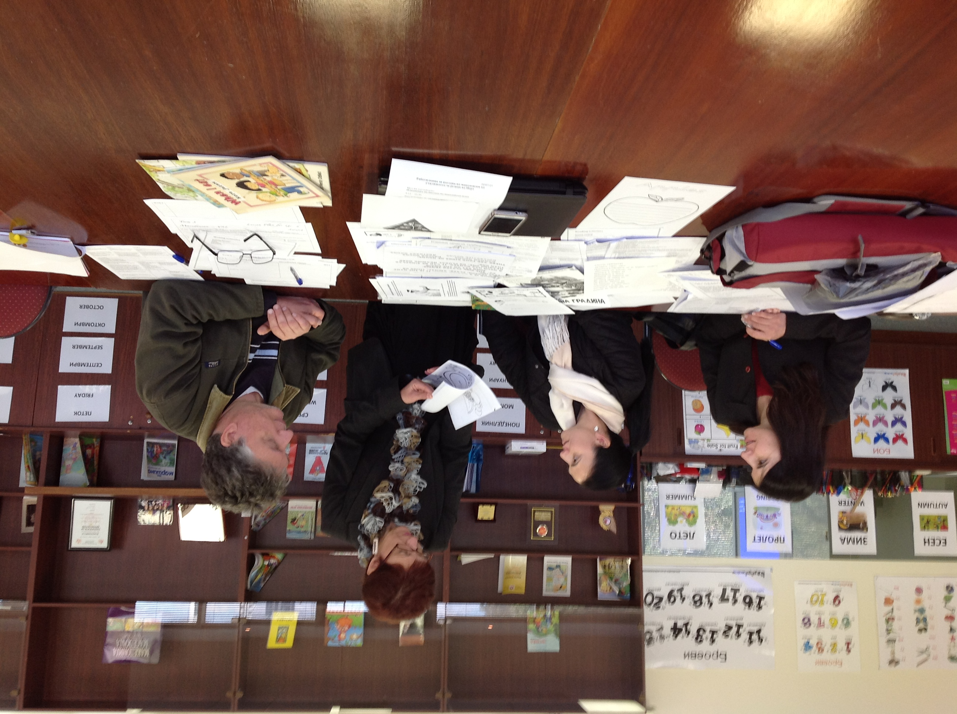
The Macedonian Community Language School is committed to providing quality education and encourages teachers to engage in professional development to strengthen their practices and to meet the needs of students.
In July we were very fortunate to have Ms Jovanka Smilevska from Lalor North Primary School’s Macedonian Bi-Lingual Program in Victoria provide professional development to our teachers. The subject of Ms Smilevska’s delivery was Lesson Planning and Design.
All teachers and administrative staff benefited greatly from Ms Smilevska’s long standing expertise.
Open Classes
During the week of 8 to 14 September, the general public were invited to experience what happens in our language classes. There were some new faces and subsequently new enrolments have resulted. Thanks to everyone who came along to see how our school operates.
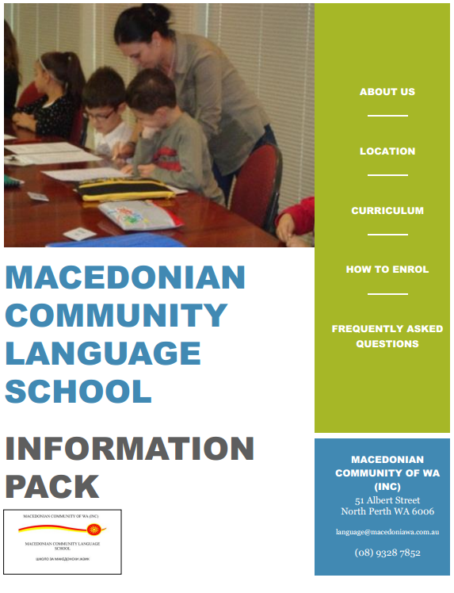
2014 Enrolments and Information Pack
Enrolments for 2014 are now open. An Information Pack has been developed to support students when enrolling. The supporting material provides information about the Macedonian Community Language School including:
- administration;
- location;
- curriculum;
- enrolment procedures;
- the 2014 Enrolment Form; and
- frequently asked questions.
We strongly recommend all prospective students read the Information Pack, which may be found on the Community’s website at www.macedoniawa.com.au. Don’t forget to tell your friends that enrolments for Macedonian language classes are now open.
Bogorodica
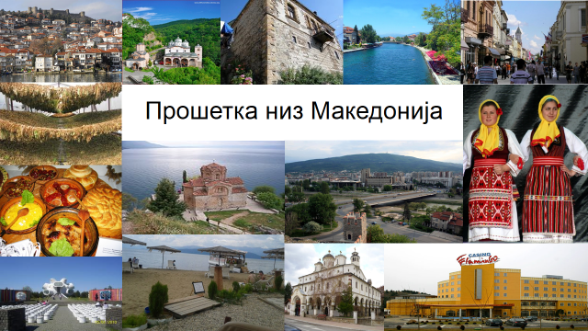
Congratulations to all students who performed at the Bogorodica Community event in August. This performance celebrated the achievements of our students and the Macedonian Community Language School’s second year of operation. A dedicated poem, Prosetka Niz Makedonija (Tour of Macedonia), was chosen for the occasion and was complemented by a presentation of student work from our middle class. All present delighted in their work and took great pleasure in their language skills. Well done to all students.
Calendar of Events
With Term 4 approaching and the lead up to Christmas there is still a busy schedule of events and activities yet to happen before the end of the year. Please diaries the following relevant events and dates in your calendars:
Macedonian Community Language School Annual Picnic Sunday, 27 October 2013
Senior Classes End-of-Year Dinner Tuesday, 12 November 2013
Junior and Middle Class Presentations Saturday, 24 November 2013
Sv Nikola Community Event Sunday, 22 December 2013
Contact Us
For language school related enquires please email language@macedoniawa.com.au. For general enquiries please email admin@macedoniawa.com.au or telephone 9328 7852. All suggestions are welcome.

