ADVICE ON UPCOMING AUSTRALIAN CENSUS
10 AUGUST 2021
MACEDONIAN COMMUNITIES COUNCIL OF AUSTRALIA
23 July 2021
Dear Fellow Australian Macedonians,
The Australian Census 2021 will take place on Tuesday 10th August 2021.
As in the past, the Macedonian community is disadvantaged in filling out the census as many of the options for filling out census questions which are afforded to other ethnic groups are denied to Australians of Macedonian descent.
To this end we have prepared some suggestions as to how best to answer some of the pertinent questions in a manner which will truly gauge and reflect how many Australians of Macedonian origin there really are in Australia. In responding to Questions 16, 18 and 19 (your place of birth and place of birth of your father and mother respectively) please do not use the offensive, illegal and unconstitutional term North Macedonia to indicate your place of birth. In addition, even though you may have been born in the Republic of Macedonia during the period that it was a part of Yugoslavia, it is very important that you do not respond to the Questions 16, 18 and 19 with an answer of “Yugoslavia”, as a separate category exists for this answer and you will therefore NOT be counted as originating from the Republic of Macedonia.
The recommended answers below will give the Macedonian Community in Australia a fairer and more accurate representation in the Census and we encourage you to use these answers if they are a true reflection of your ancestry, religion and cultural background.

Chris Angelkov,
Chairman, Macedonian Communities Council of Australia

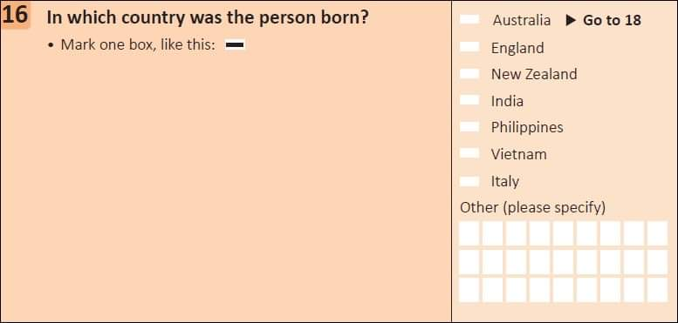
If you were born in Macedonia please print “MACEDONIA” in the boxes under Other (please specify).
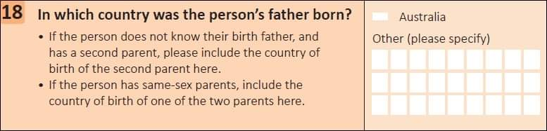
If your father was born in Macedonia please print “MACEDONIA” in the boxes under Other (please specify).
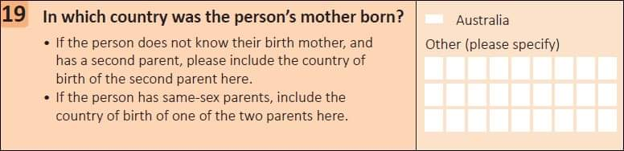
If your mother was born in Macedonia please print “MACEDONIA” in the boxes under Other (please specify).
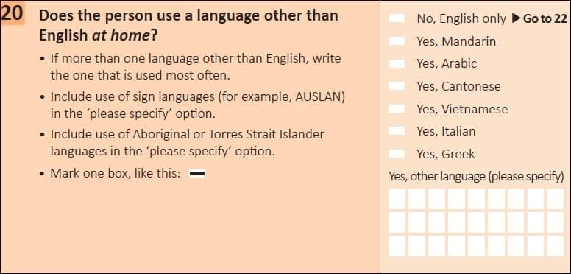
If you speak Macedonian, irrespective of how fluently you do so, you should in the space below the category “Yes, other language (please specify)”, write/type: MACEDONIAN.
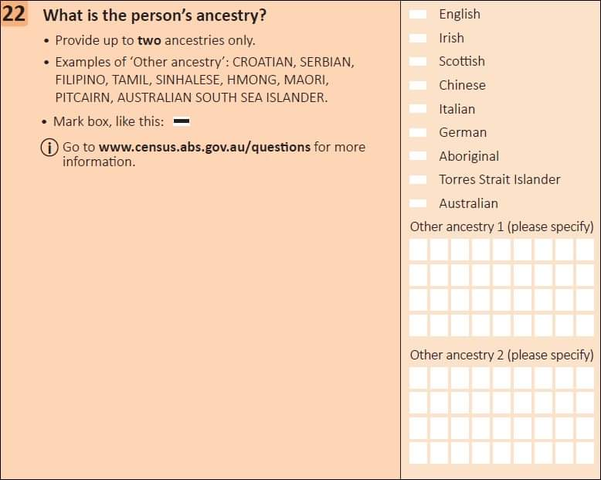
Regardless of where you were born (Republic of Macedonia, Aegean Macedonia, Pirin Macedonia, Mala Prespa, other parts of Greece, Bulgaria, Albania, Serbia, Kosovo, Australia or elsewhere) your ancestry (heritage/background) is Macedonian. For this question, you may count back three generations (parents, grandparents, great grandparents). Please print “MACEDONIAN” in each box under Other ancestry 1 (please specify) and if you have other ancestry fill in Other ancestry 2 accordingly with whatever other ancestry you have.
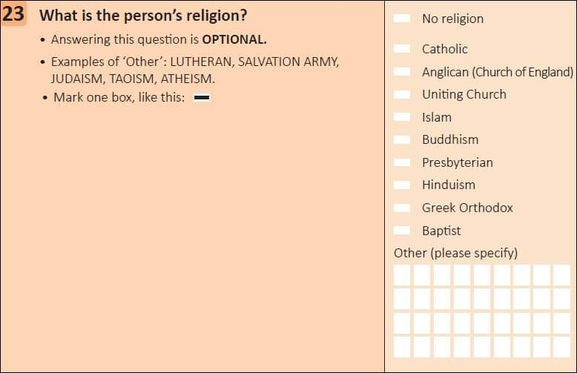
If you identify as belonging to the Macedonian Orthodox religion you should: In the space below the category “Other – please specify” write/type: “MACEDONIAN ORTHODOX”. Be aware that if you respond simply with “Orthodox”, a separate category exists for this and you will not be counted as “Macedonian Orthodox”.

